The ***Azure CHR Walkthrough*** series was inspired and builds upon the work of the tutorial give [here](https://pebkac.io/2016/10/mikrotik-chr-in-azure-part-two/). **Section 1** creates a Azure hosted mikrotik router and the following will walk you through the steps of creating a CHR, and connecting to it through WinBox. **Section 2** will create a local vm based mikrotik router which can then be connected to using WinBox and **Section 3** outlines the steps to make CHR of Section 1 and local VM based Mikrotik router of Section 2 communicate with each other.

**Section 1: Steps to create Azure CHR (Cloud Hosted Router) that all of your other Mikrotik routers can connect to:**

* 1. You'll need to create a resource group, NIC, and storage account through the Azure Portal – you will need the names of all 3 for step 1.7.
  2. Upload Mikrotik VHDX to the storage account’s blob storage created in step 1.1 here's a [VHD](https://s3.amazonaws.com/pebkacio/blog/chr-6.37.1.vhd) of 6.37.1. Upload the VHD file to the storage account created in Step 1.1, as a blob page. Copy file Image URL for Step 1.7.
  3. Download [Azure CLI](https://docs.microsoft.com/en-us/cli/azure/install-azure-cli?view=azure-cli-latest)
  4. Open Windows Power Shell after you have downloaded Azure CLI and type the following after you have typed “az login” which should let you know if Azure CLI is installed correctly and how to authenticate.
  5. Type *Connect-AzureRmAccount* in case of Powershell and see the description given for the subscription and account, the information should match the information created in Step 1.1 above
  6. 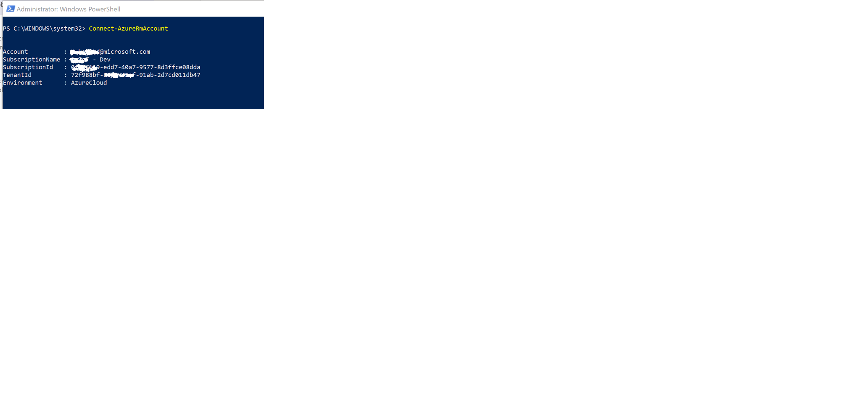Note when you type *Connect-AzureRmAccount*, you will be directed to a pop-up to enter your credentials and that will authenticate your account and display your subscription information correctly (Figure 1.1) or asked to open a page and enter a code, doing so will authenticate you and display the following:

**Figure 1.1**

* 1. 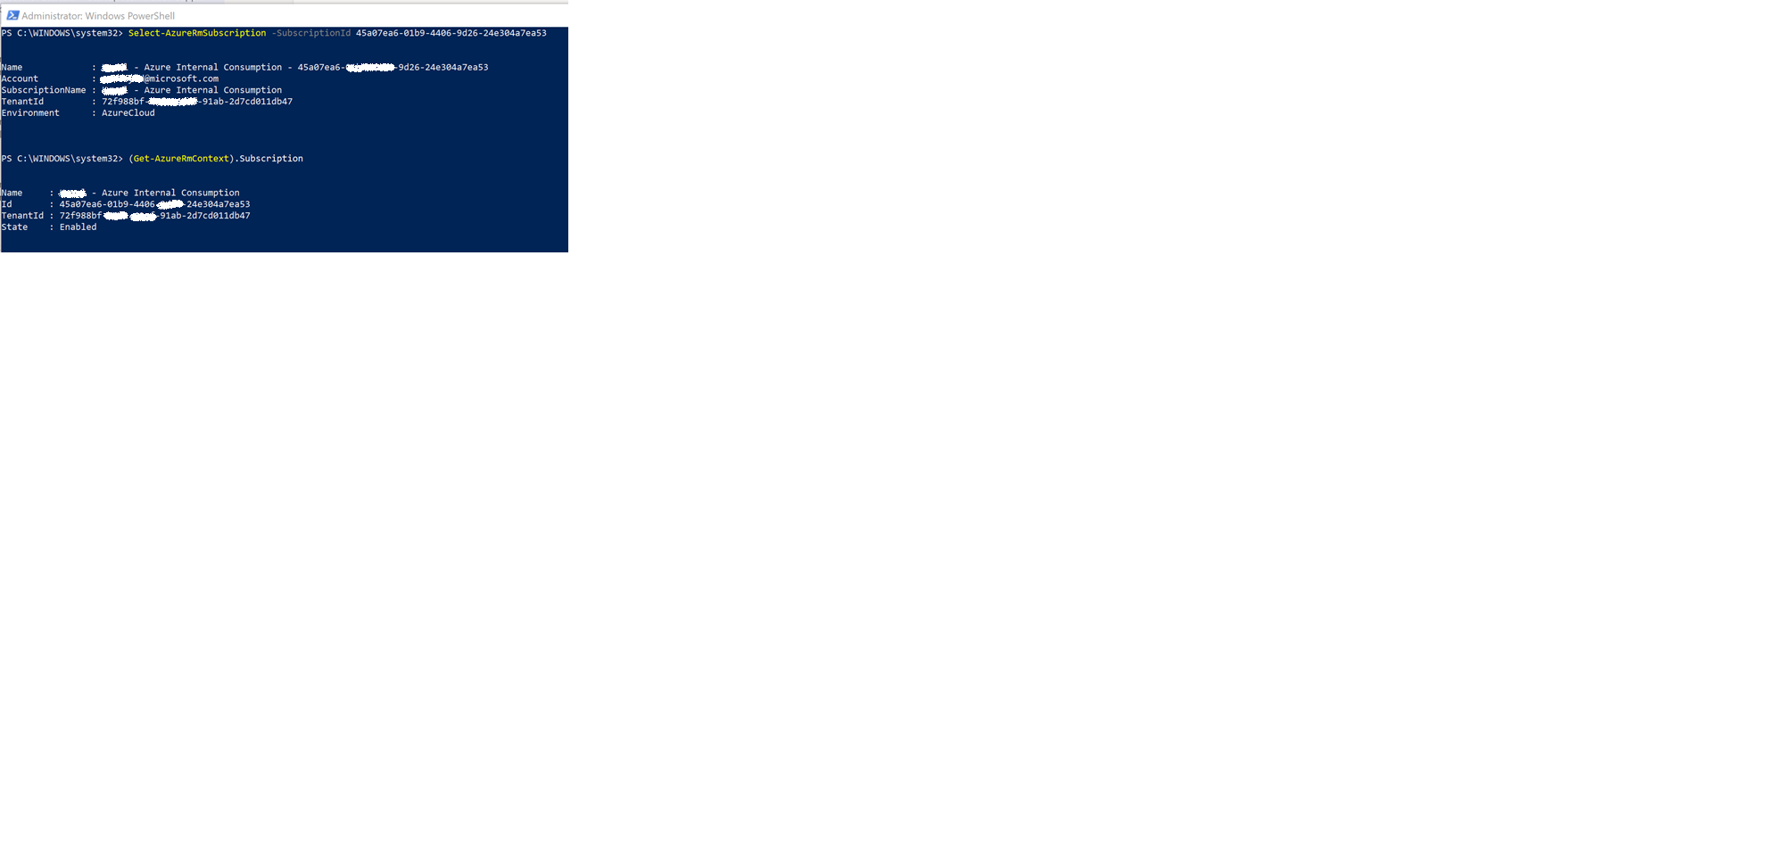If you have multiple subscriptions, only the default one will be displayed in Step 1.5. In order to select the subscription in which the resources you created such as storage account, resource group etc are located, type the following as shown in Figure 1.2 *Select-AzureRmSubscription -SubscriptionId 45a07ea6-01b9-4406-9d26-24e304a7ea53*

**Figure 1.3**

* 1. The following instructions (Appendix 1) are to be pasted into Windows Powershell after the highlighted values in red are replaced with your own values, ensuring the following
  2. SubscriptionId is the same as where the resource group, storage account and NIC, created in Step 1.1 are located.
  3. The VM name is whatever you want the new CHR Azure VM to be called.

1. Plug in the ResourceGroupName and StorageAccountName from the ones created in Step 1.1
2. LocationName is region where you want to create the VM, depending on which region you select, it will select the VMSize you can select as some VM sizes are region specific and are not available in other regions. In order to view all the regions available to you use the command *Get-AzureRmLocation*
3. List of VMSizes or available options can be viewed by using the following commands:
   * + *Get-AzureRmVMSize -Location "West Europe"*
     + *Get-AzureRmLocation | Where-Object {$_.Location -eq "westeurope"} | Get-AzureRmVMSize*

Note that the first example uses the location name as input, the second example uses the display name extracted from the list returned in d.

1. InterfaceName is the name of the NIC you created in Step 1.1 (Help in creating an NIC through the Azure portal is given in Appendix 2).
2. SourceImageUri is the url of the file uploaded to blob storage under the storage account created in Step 1.1 (See Appendix 3)
   1. 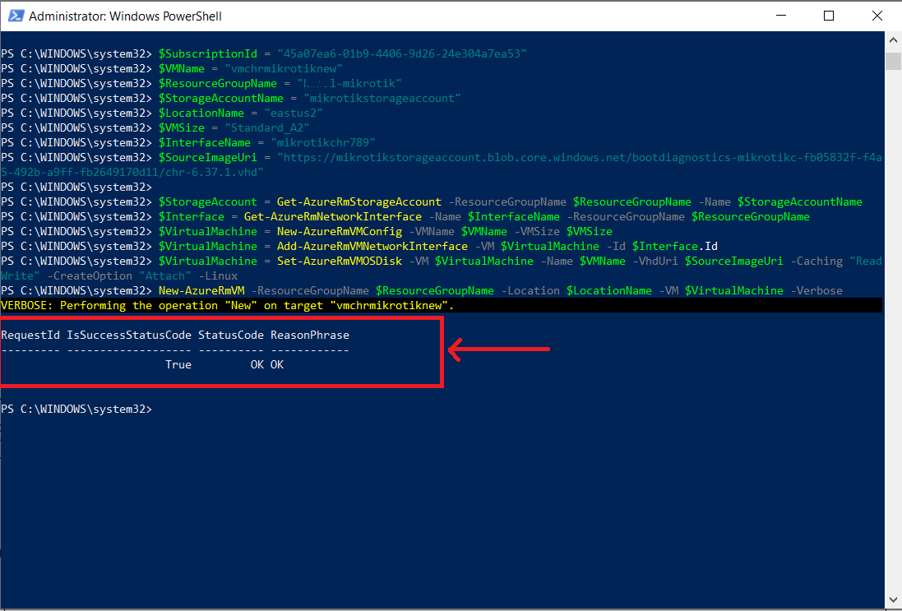Once the VM has been successfully created you will see the following message highlighted in Figure 1.4 with a red box.

**Figure 1.4**

* 1. The next step is to assign the created VM with a public IP through the Azure portal (Appendix 4) gives the step to create a public IP for the created VM
  2. Once your VM has a public IP address attached to it, [download WinBox](https://mikrotik.com/download) to connect to the VM as shown in (Appendix 5)
  3. **Note:** (Part 2 of this document – coming soon) will walk you through setting up the connection through VPN from on-site mikrotik router to the Azure Cloud Hosted Router (CHR) that we just created above.

**Appendix 1: Windows Powershell Script create a CHR VM**

|  |
| --- |
| $SubscriptionId = "45a07ea6-ccccccccccc-24e304a7ea53"  $VMName = "vmchrmikrotiknew"  $ResourceGroupName = "rg-chrmikrotik"  $StorageAccountName = "sa-mikrotik"  $LocationName = "eastus2"  $VMSize = "Standard_A2"  $InterfaceName = "mikrotiknic123 "  $SourceImageUri = "https://mikrotikstorageaccount.blob.core.windows.net/bootdiagnostics-mikrotikc-1a2e4c65-125f-4f4e-924f-5a01030698d9/chr-6.37.1.vhd"  $StorageAccount = Get-AzureRmStorageAccount -ResourceGroupName $ResourceGroupName -Name $StorageAccountName  $Interface = Get-AzureRmNetworkInterface -Name $InterfaceName -ResourceGroupName $ResourceGroupName  $VirtualMachine = New-AzureRmVMConfig -VMName $VMName -VMSize $VMSize  $VirtualMachine = Add-AzureRmVMNetworkInterface -VM $VirtualMachine -Id $Interface.Id  $VirtualMachine = Set-AzureRmVMOSDisk -VM $VirtualMachine -Name $VMName -VhdUri $SourceImageUri -Caching "ReadWrite" -CreateOption "Attach" -Linux  New-AzureRmVM -ResourceGroupName $ResourceGroupName -Location $LocationName -VM $VirtualMachine -Verbose |

**Appendix 2: Creating NIC (Network Interface)**

2.1 The following walks through the creation of network interface card (NIC). Type in Network Interface in search bar (Figure 2.1) and then click on Add button  in Figure 2.2, filing in all the details leaving the subnet address as the default one provided and choosing the resource group to be the same as created in Step 1.1.

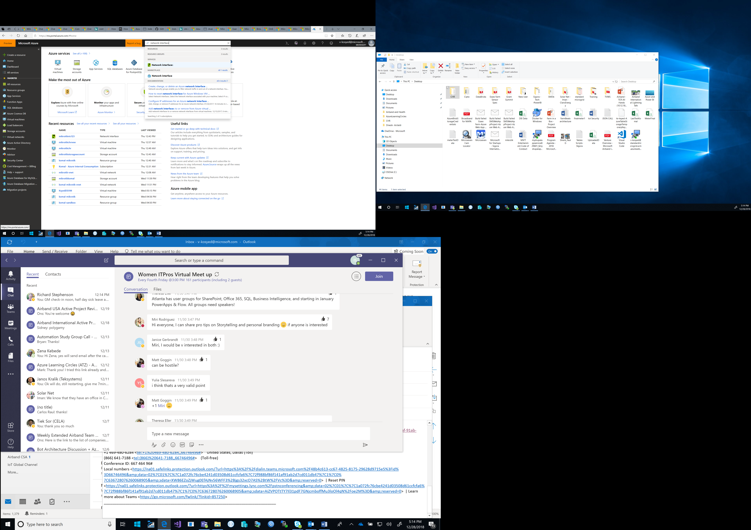

**Figure 2.1**

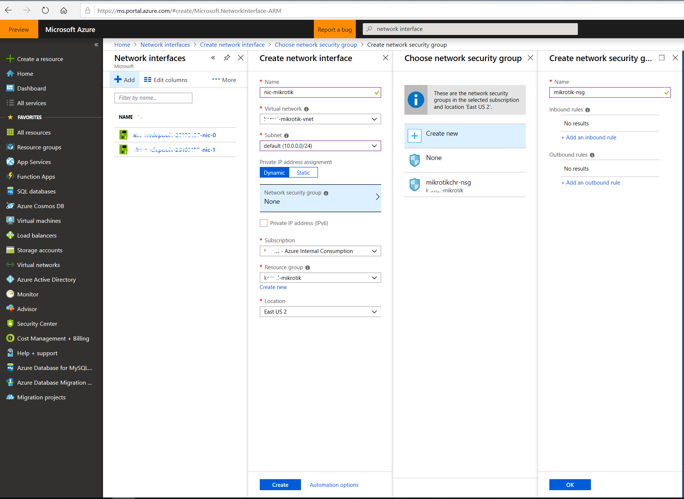

**Figure 2.2**

**Appendix 3: Uploading VHD file obtained from Mikrotik website (VHD)**

3.1 The file available on Mikrotik website for [download](https://mikrotik.com/download) of the Cloud Hosted Router is uploaded as a VHDX image file. The file needs to be converted to a VHD file and uploaded to blob storage under the storage account as shown in Figure 3.1

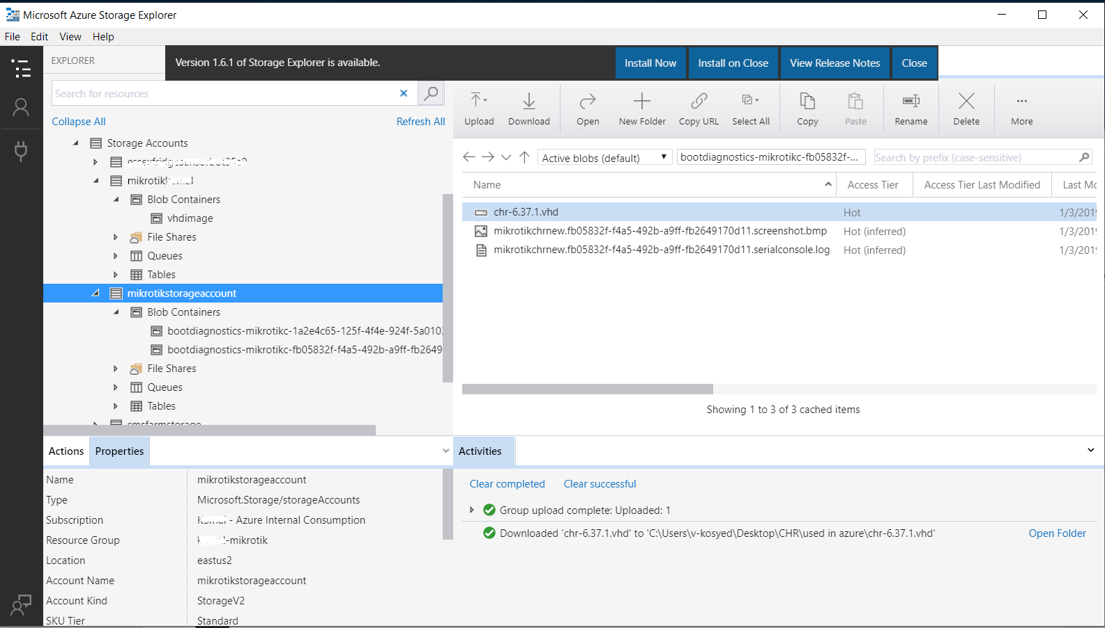

**Figure 3.1**

**Appendix 4: Configuring public IP address for the set VM**

4.1 The Public IP address settings need to be enabled and then the IP address is created as shown in Figure 4.2. This IP address is very important for connecting to the Virtual Machine using Winbox as shown in Appendix 5

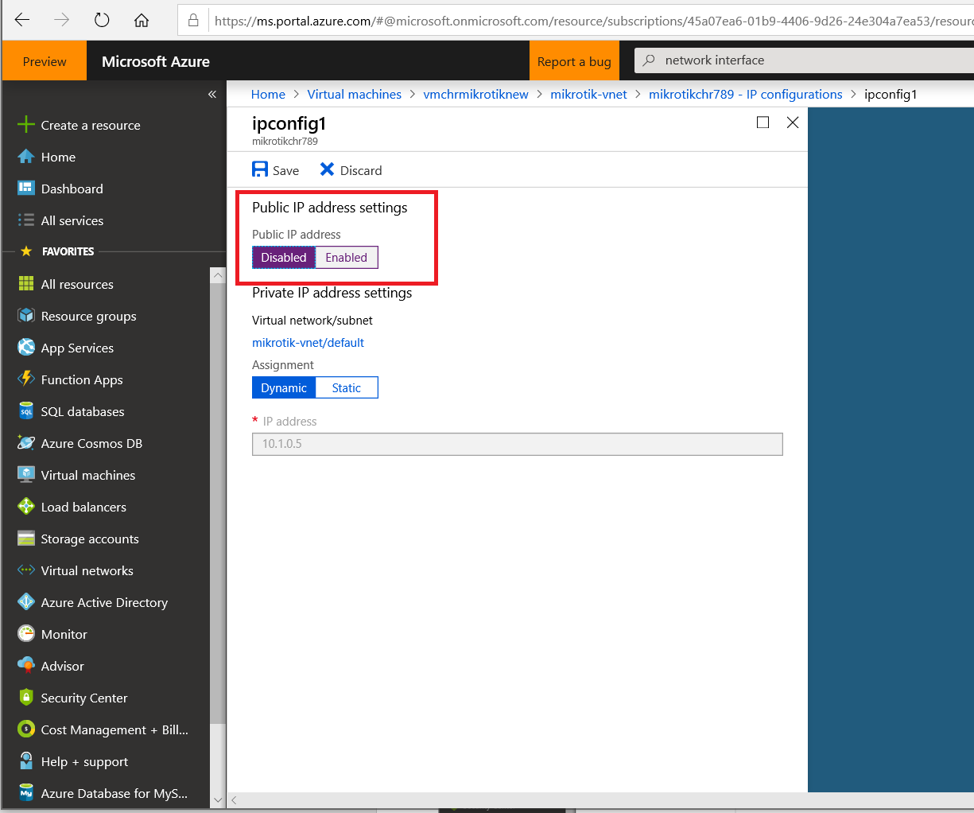

**Figure 4.1**

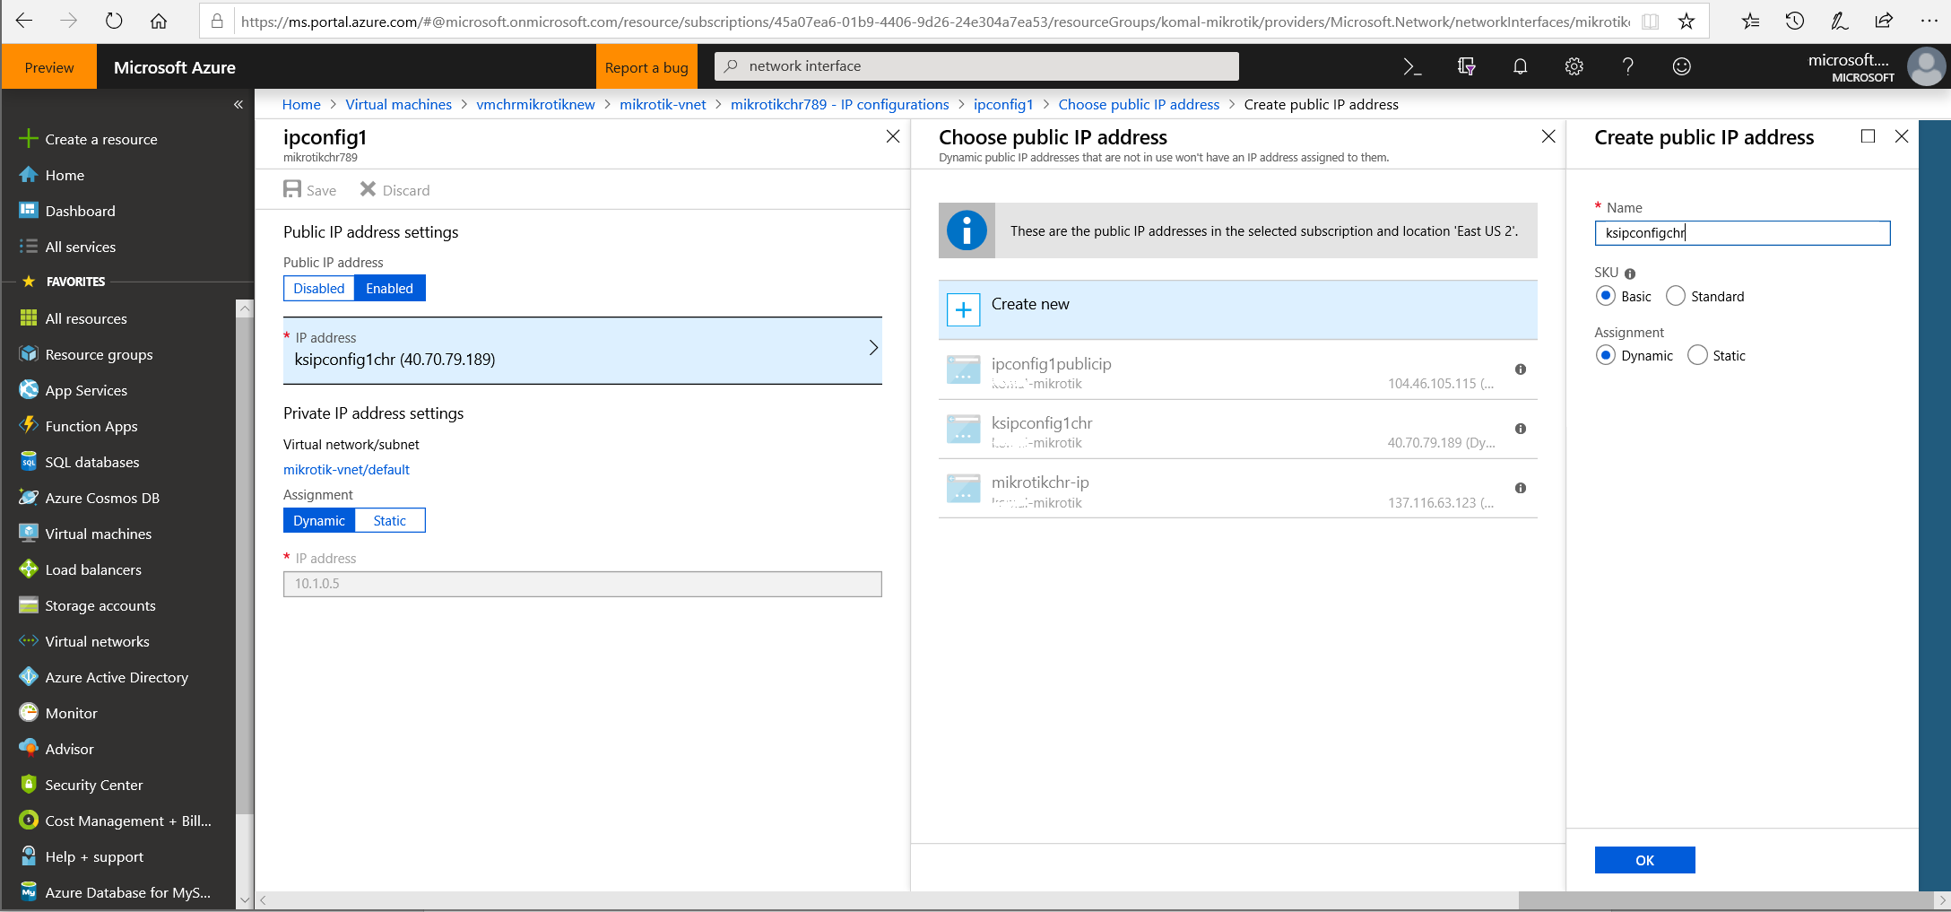

**Figure 4.2**

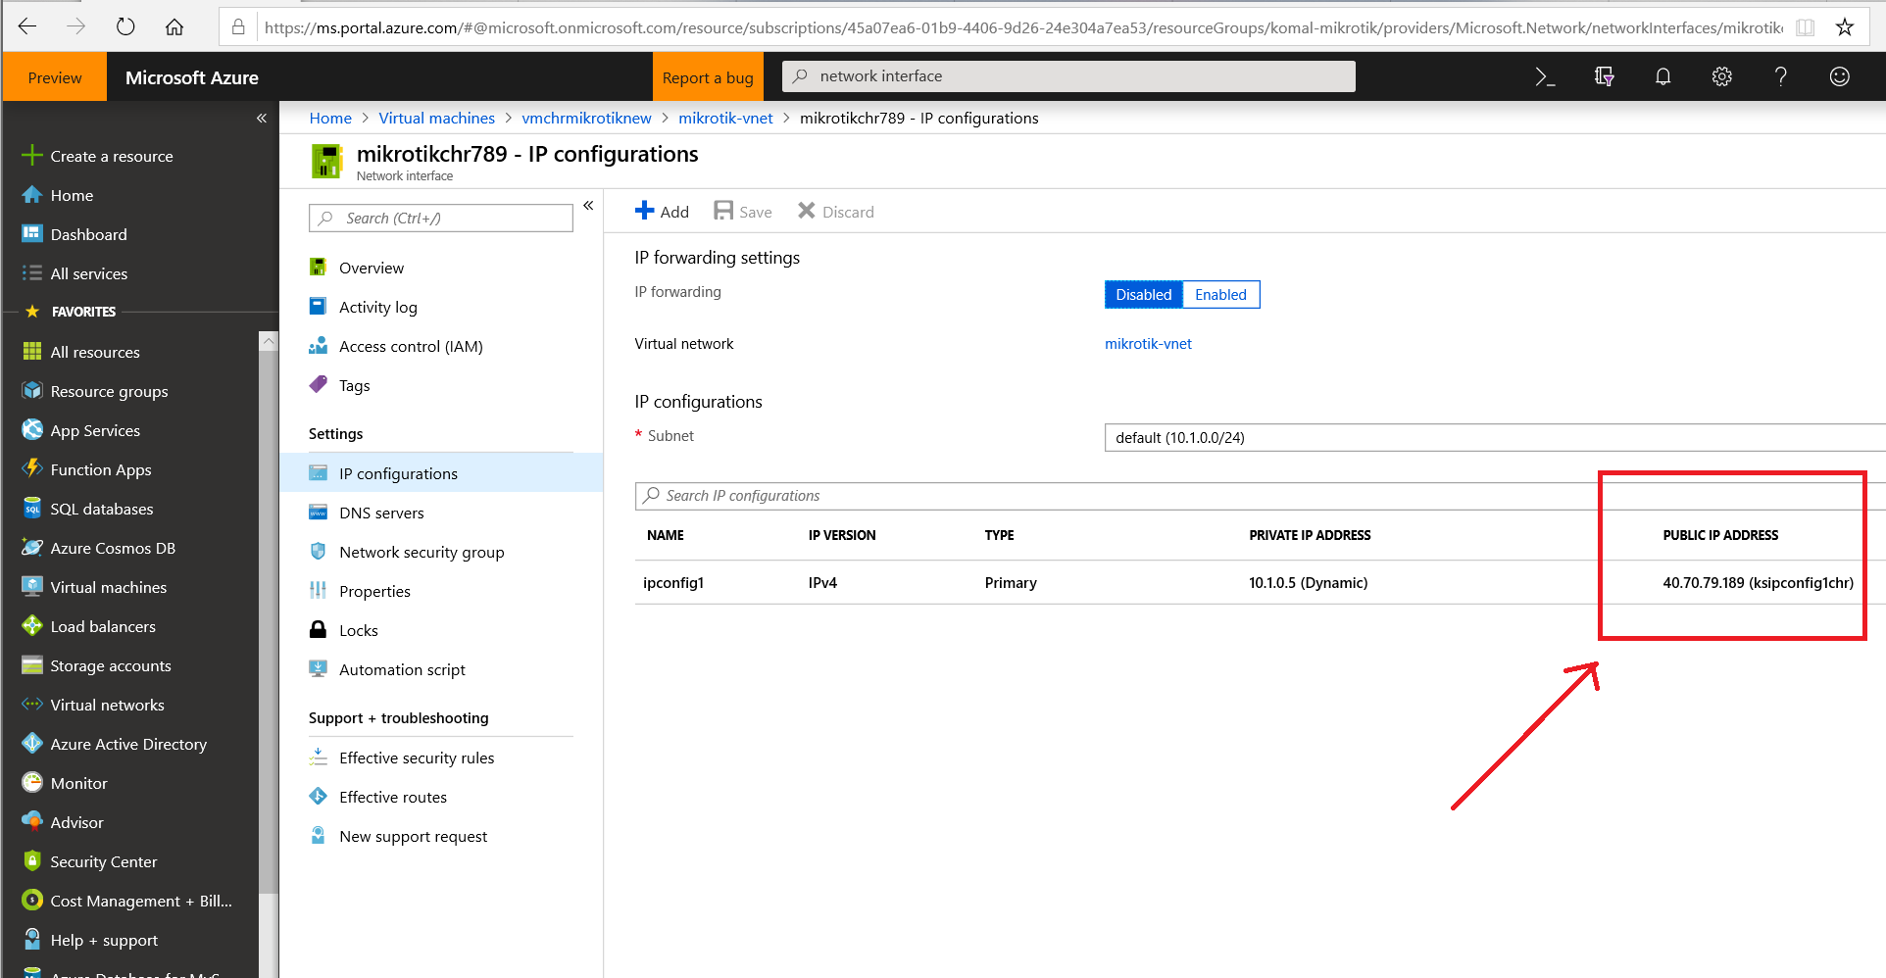

**Figure 4.3**

**Appendix 5: Windows Powershell Script create a CHR VM**

5.1 Install WinBox from the link given [here](https://mikrotik.com/download) as shown in Fig 5.1

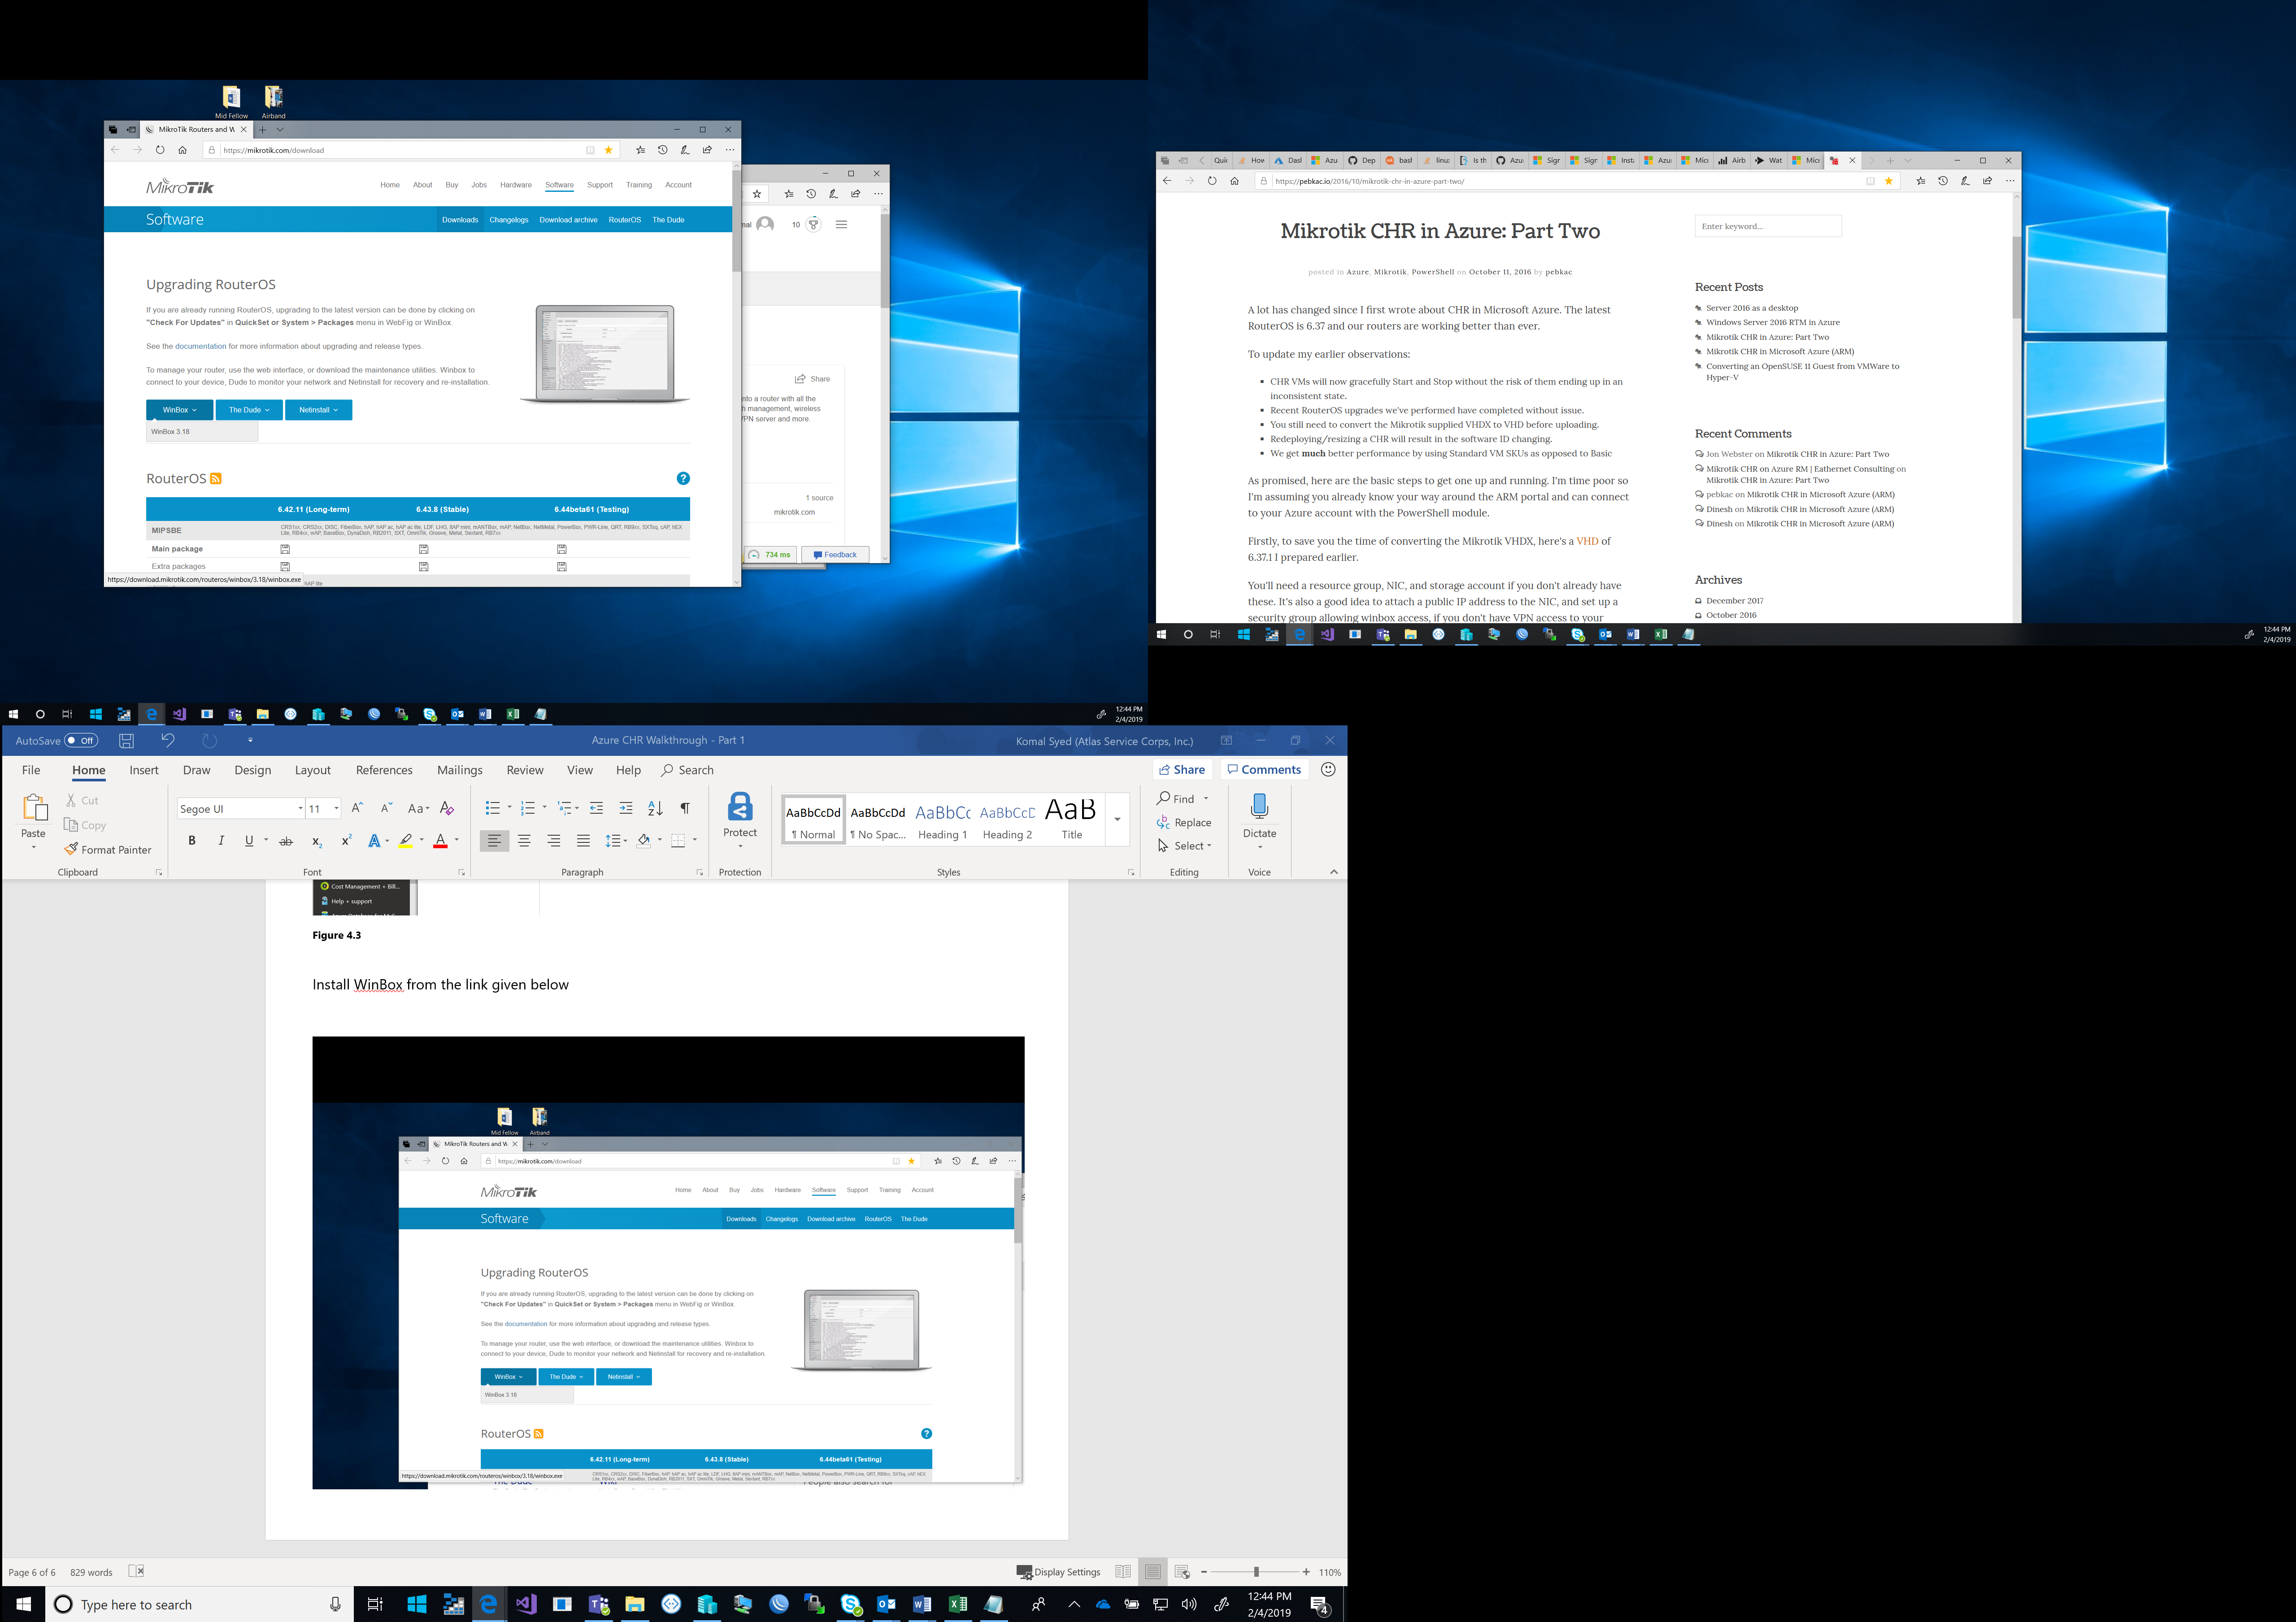

**Figure 5.1**

5.2 Open WinBox and enter the IP address of the Azure VM that was created in Part 1 of the Azure CHR Walkthrough series – to find the IP address you can also open the Azure Dashboard as shown in Fig 5.2 and click on Virtual Machine

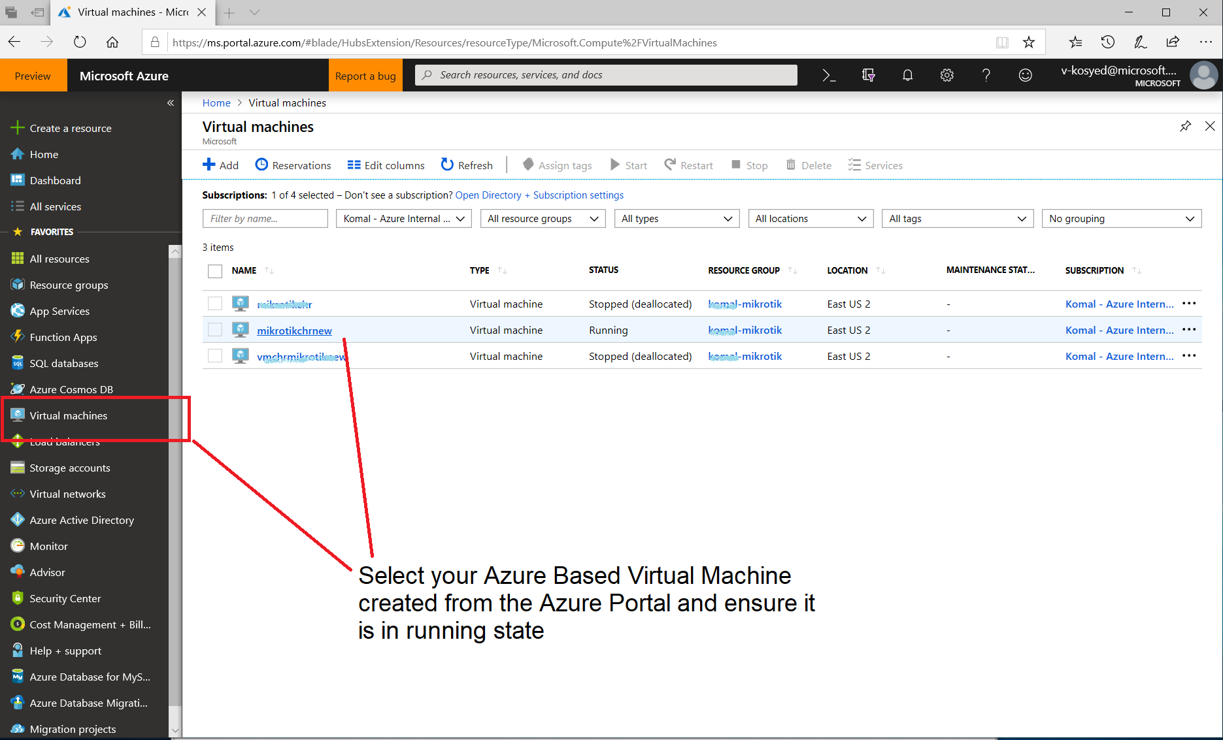

**Figure 5.2**

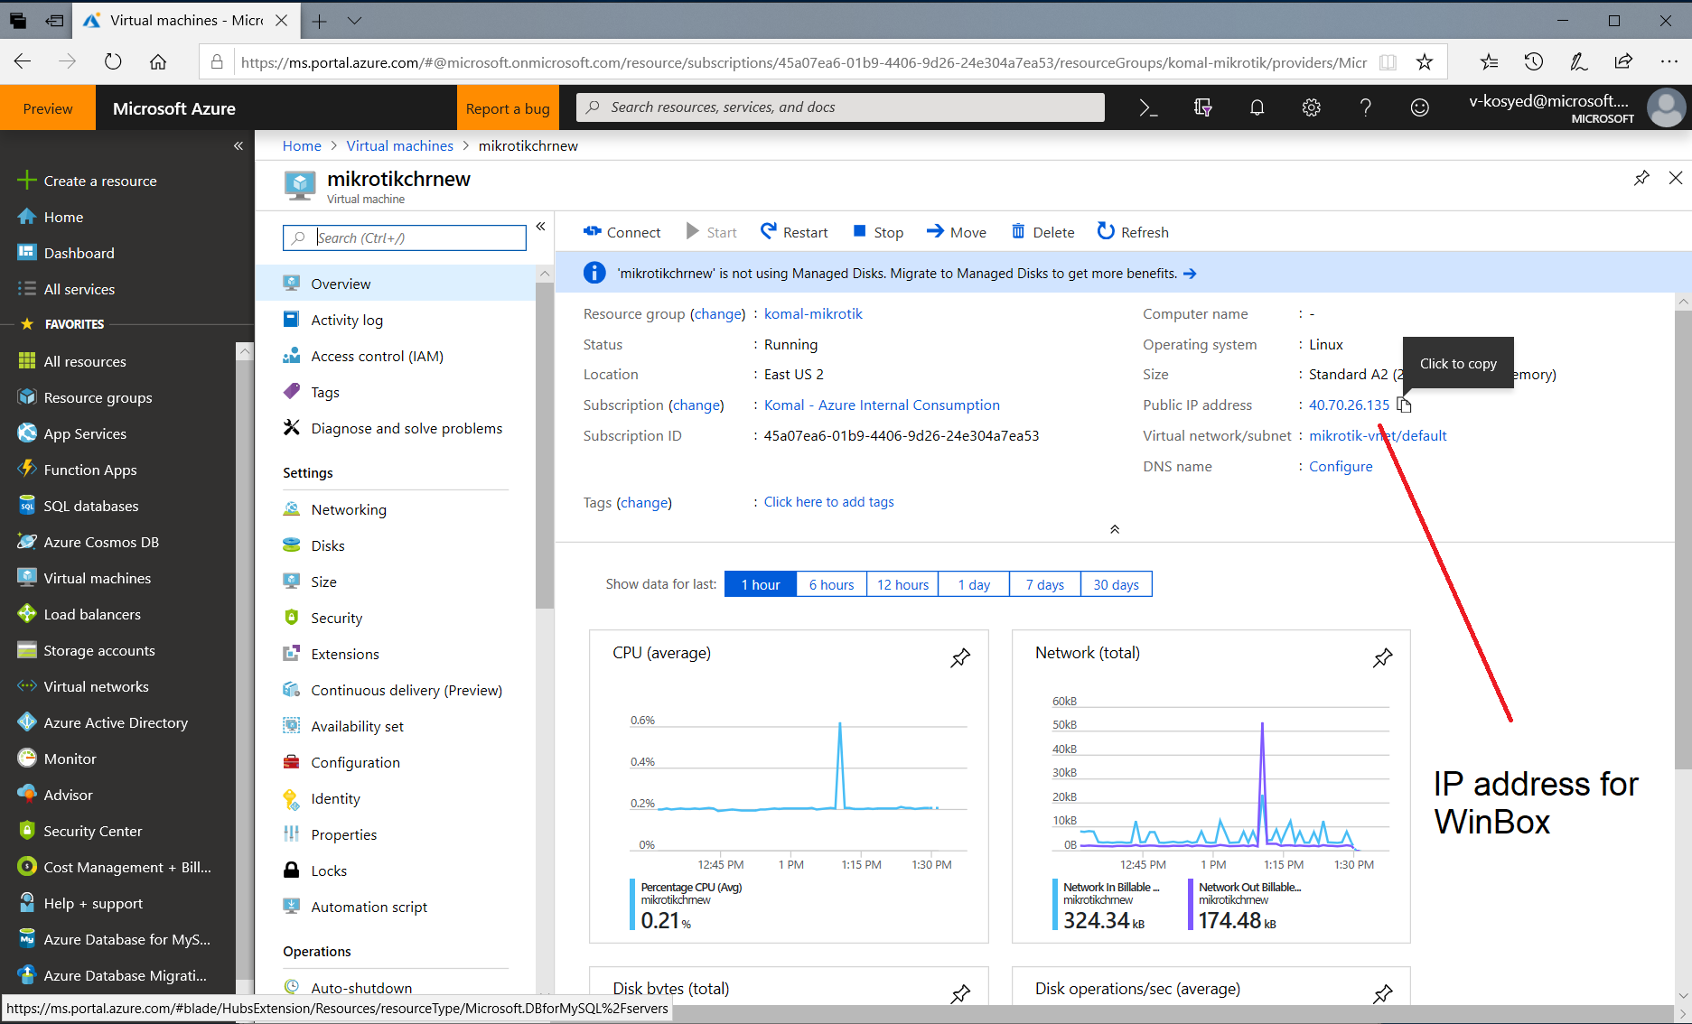

**Figure 5.3**

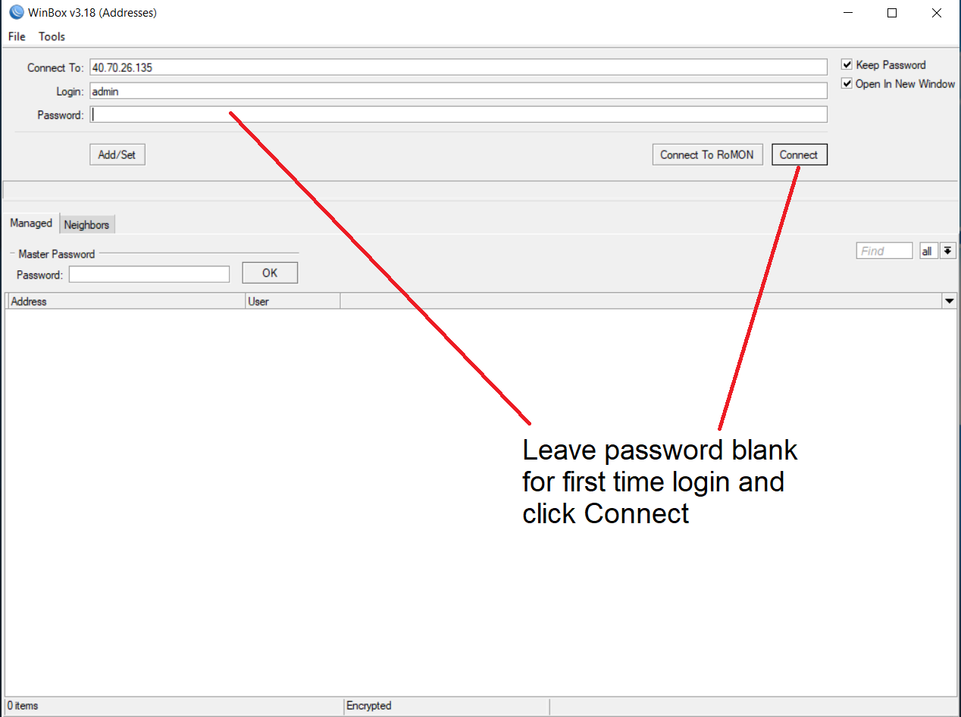

**Figure 5.4**